**ROLL NO. - *210100166* CLASS – *D3/T4***

 This week I learnt about multi electron system and I understand how Hamiltonians differ from single electron system. For helium atom the Hamiltonians ***Ĥ1*** and ***Ĥ2*** are one electron Hamiltonians similar to that of hydrogen atom. The total electronic wavefunction of n number of electrons can be written as a product of n one electron wavefunctions. Then I learnt about orbital Approximation and we get

* Net nuclear attraction perceived by an electron = Actual Nuclear attraction – repulsion by other electrons

Then concept of shielding effect is started.Due to Shielding, the electrons do not see the full nuclear charge ***Z***, but ***Zeff = Z–σ*** (σ = Shielding Constant).then I learnt about Spin angular moment. Spin orbitals are orthogonal and normalized. Quantum numbers are *n,l,m,ms.*

I also learnt about liner combination of spin orbitals. There are 4 possibilities

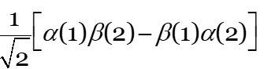, ,  **+ ** and here 1 and 2 is indistinguishable and

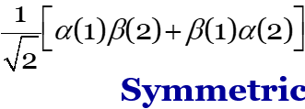



I understand the 6th postulate that is the complete wavefunction of a system of identical fermions (e.g. electrons) must be anti-symmetric with respect to interchange of all their coordinates (spatial and spin) of any two particles and learnt about Pauli’s principle. And then learnt singlet and triplet excitation state of He atom. And learnt about effective nuclear charge and its application.